**Application of the Beer-Lambert Law to Track the Concentration of Aqueous Copper(II) Ion in an Oxidation Reaction**

16 September 2023

CHEM 1310L Laboratory

*Data and Results*

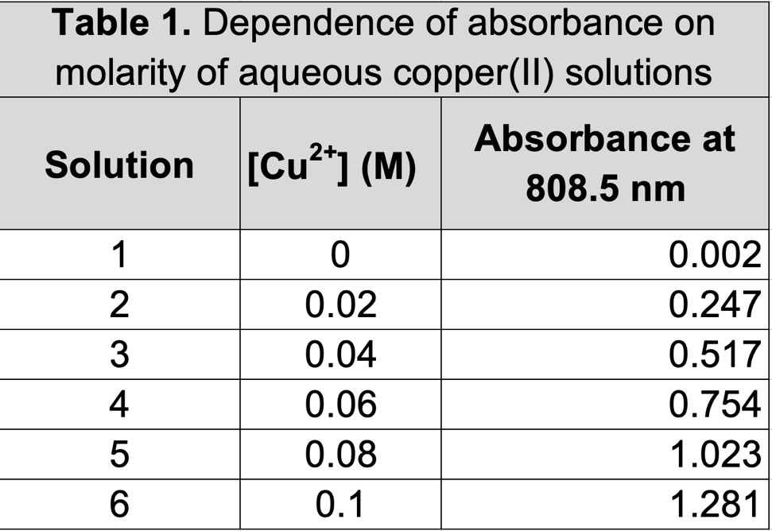

**Table 1.** Dependence of maximum absorbance on molarity of aqueous copper (II) solutions.

**Figure 1.** Beer-Lambert plot at 808.5 nm for aqueous copper (II) ion.

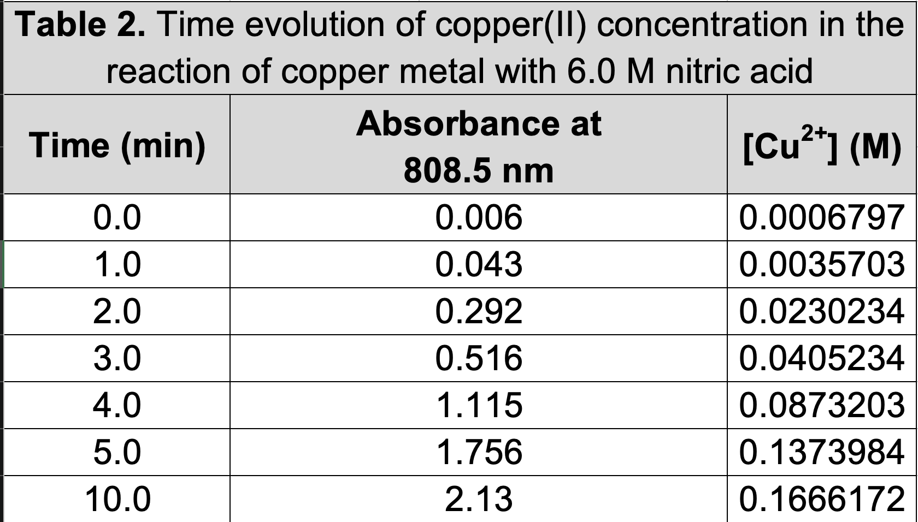

**Table 2.** Time evolution of copper (II) concentration in the reaction of copper metal with 3.0 M nitric acid.

**Figure 2.** Time dependence of the reaction of copper metal with 3.0 M nitric acid.

*Discussion*

To begin with part A of the lab, we must prepare solutions of specific concentrations for aqueous copper (II). Beginning with a stock solution of .1M copper (II) at 50mL, we must dilute certain amounts of this sample to achieve the desired concentrations of solutions 2-5. Consider solution 2, a 0.020M solution of copper (II). To achieve this concentration, we refer to the following equation which describes the process of dilution, or the relation of two solutions of different molarities.

$$M_{1}V_{1}= M_{2}V_{2}$$

We know that the desired concentration of solution 2 is 0.020M at 10mL. As such, we can easily substitute these values for $M_{2}$ and $V_{2}$. Additionally, since we are mixing this solution from a stock solution of 0.100M copper (II), we can substitute this value for $M_{1}$. This leaves us with the following equation where we solve for $V_{1}$ by means of simple algebra.

$$(0.100)V_{1}=\left(0.020\right)(0.010)$$

$$V_{1}=\frac{(0.020)(0.010)}{(0.100)}$$

To prepare solution 2, we need 2mL of our 0.1M copper (II) stock solution. Therefore, we need 8mL of water to dilute it and bring it up to the desired 10mL.

Prior to measuring the absorbance of solutions 1-6, we determined the wavelength at which we will measure the absorbance for copper (II) to be 808.5 nm through a calibration sequence of the visual spectroscopy machine.

After performing part A of the lab, we obtained a specific absorption value for each solution 1-6. The following equation derives a linear relationship between the absorption of a solution and that solution’s molarity.

$$A= εl\left[Cu^{+}\right]+σ$$

Because the cuvette’s size during the experiment remained constant, the variable $l$ turns into a constant of 1. As such, graphing the values of absorption with respect towards its concentration produced a linear relationship as seen in Figure 1. The equation for the line of best fit is as follows:

$$y= 12.8x-.0027$$

Where when substituting the variables for their actual values according to the graph produce the equation

$$A= 12.8\left[Cu^{+}\right]-.0027$$

Therefore, the slope of the line of best fit, 12.8, represents the molar absorption coefficient ε. Additionally, the y intercept, $-.0027$, represents our error term, $σ$.

During part B of the experiment, we determined that the rate at which the molarity of solution changes was nonlinear and was in fact increasing. The results from part b of the lab illustrates how over time, the molarity of copper (II) in the aqueous nitric acid solution increases (Figure 2). Because the molarity of the aqueous nitric acid solution changes with respect to the concentration of copper (II), it is evident that a chemical reaction is happening.

For part B of the experiment, the concentration of copper (II) at each sample point (e.g., 1min, 2min, 3min, etc.) is initially unknown but can be deduced using the equation relating absorbance to the concentration of copper.

$$A= εl\left[Cu^{+}\right]+σ$$

Consider the concentration of the copper sample solution at 3mins. The absorbance value @ 3mins is 0.516.

$$0.516= 12.8\left[Cu^{+}\right]-0.0027$$

Rearranging the equation to isolate the concentration of copper (II), we get:

$$\left[Cu^{+}\right]=\frac{0.516+0.0027}{12.8}$$

$⇒\left[Cu^{+}\right]=0.0405234 M$@ 3 mins

*Conclusions*

The research question being investigated in this experiment is what is the average rate of reaction of copper with nitric acid? Through parts A and B of this experiment, we were able to determine how copper does in fact obey the Beer-Lambert law in that there is a linear relationship between the concentration of copper (II) and its absorbance of light at a wavelength of 808.5 nm. As a result, when observing the reaction of copper with nitric acid and determining the concentration of aqueous copper (II) in the solution at various points in the reaction, we saw how the reaction was not linear but followed a logistical growth curve where at the beginning, the reaction occurred at a fast rate however towards the end, the reaction began to slow down and the rate at which the concentration was increasing had stalled (Figure 2).

Considering the reaction at the atomic level, the initial rate of reaction is comparably high because of the abundance of nitric acid molecules ($HNO_{3}$) and copper in the sheet. As time went on, the number of molecules of nitric acid and copper within the sheet had reduced significantly, and as such the reaction had begun to slow as seen in Figure 2.

Nonetheless, the average rate of reaction is determined through a line of best fit or a trendline of the data. The following illustrates a trendline and from there, we can see the average rate of reaction for the full 10 minutes is $0.0188\frac{M}{min }$ meaning the molarity of copper (II) had increased by 0.0188 every minute.

**Figure 3.** Time dependence of the reaction of copper metal with 3.0 M nitric acid with trendline.